How autism can be hidden from society using psychological strategies
July 24, 2019 11.45am BST

Authors

Lucy Anne Livingston: Researcher, Institute of Psychiatry, Psychology and Neuroscience, King's College London
Francesca Happé: Professor of Cognitive Neuroscience, King's College London
Punit Shah: Assistant Professor (Lecturer) in Psychology, University of Bath

Autism is usually identified by doctors during childhood, but a growing number of people are now being diagnosed with the condition in adulthood. A later diagnosis can be challenging because many intellectually able adults have developed “compensatory” psychological strategies for coping with their autistic difficulties. These can hide their symptoms from doctors, employers, and even family members.
A recent survey found that many GPs in the UK are not confident in their ability to identify autism. And compensatory strategies are now thought to be one of the main reasons for difficulty with diagnosis in adults.
Yet there is little guidance for doctors on detecting these strategies, and for parents and teachers on whether they have a positive impact. And so far, most evidence of these strategies has been anecdotal, often from secondhand observations, rather than the lived experiences of autism. (This reflects a broader issue of participants and patients’ voices being undervalued in medical research.)
Our new research explored these psychological strategies in more detail, and also aimed to provide a voice for autistic people who, despite their difficulties, are motivated to fit into non-autistic society.
Using large-scale online data collection, autistic adults from around the world described their experiences of using psychological strategies to fit in. They frequently reported copying hand gestures, eye contact and facial expressions from others, and learning when to laugh at jokes even when they didn’t understand them. One said:
If I acted like that person over there, no one would know that I was struggling inside … I made mental lists of the things I had to remember to say or do.
Most participants felt that their compensatory strategies were a key reason why autism was not diagnosed in childhood, and why their difficulties continued to be overlooked by others. One commented:
A lot of people who know me superficially express surprise that I am autistic. I don’t take it as a compliment and I often want to respond [by saying]: “Do you realise how much damn hard work it is to seem this normal?”
Participants also said that using these strategies took a lot of mental energy, contributing to poor mental well-being:
The [compensatory] experience feels like you are running a marathon while non-autistics are casually walking. It is draining … It fuels my anxiety.
But not all experiences of compensatory strategies were negative. The same techniques appeared to help some autistic people to live independently, get a job, and have relationships:
[With compensatory strategies] … I am liked by my colleagues and friends … I haven’t lived on the edge, lost and lonely, as I could have.
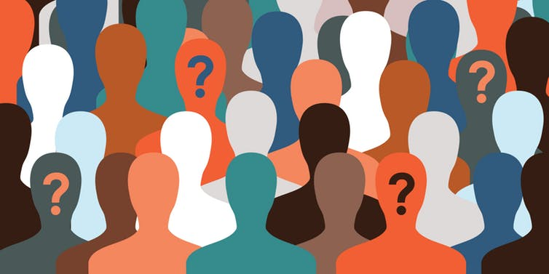Some people using compensatory strategies to fit in. Shutterstock/magic pictures
Autistic adults also suggested that non-autistic people could develop their own compensatory strategies to help create a society that is more autism friendly:
Communication is a two way street, so as much as I can understand the need to compensate in certain situations, non-autistics should develop an understanding and appreciation that there is a middle way. It’s not just their world.

Two way conversations
The research highlights the gaps between autistic adults and non-autistic society, with important implications for the diagnosis of autism and society’s views on the condition.

Read more: How accommodating workers with autism benefits employers -- and all of us

Manuals used to diagnose and manage autism make only cursory reference to compensatory strategies. Our findings will hopefully encourage formal recognition and discussion of these strategies, to improve diagnosis and support for people who don’t “seem” autistic. These will feed into autism training for GPs, which is urgently needed.
Our research also provides clues for how non-autistic people could do more when interacting with autistic people. Reducing social small talk (asking “How are you?”, for example) may actually improve interactions.
This might feel rude or awkward, but could lessen autistic people’s need to compensate in situations they would otherwise find stressful. Autistic broadcaster Chris Packham describes this experience in the same academic journal as our research.
It isn’t yet clear whether reducing small talk would be helpful, so we hope to conduct more research into this “two-way” compensation idea, drawing on the work of autistic academic Damian Milton. But overall, our findings may help autistic people to maximise the positive and minimise the negative consequences of compensatory strategies. This should in turn improve their quality of life and cohesion between autistic and non-autistic people in society.

